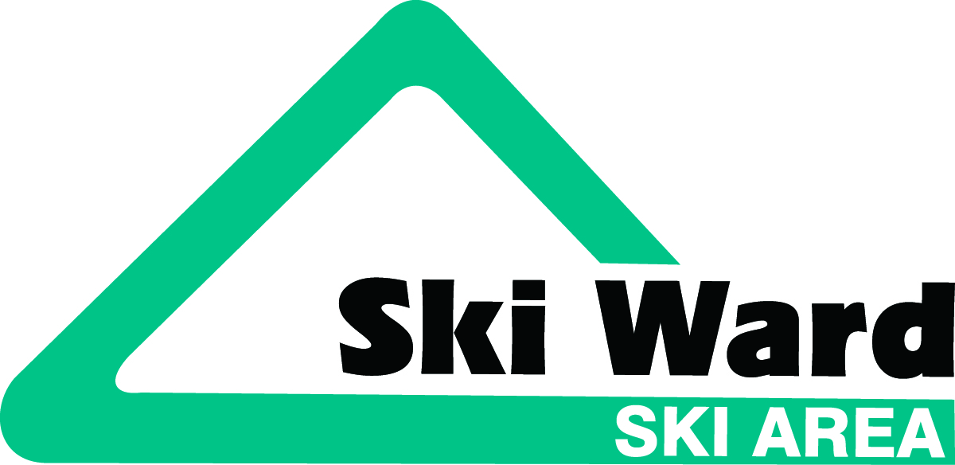
2017-2018 Lesson Program Information

All registration must be done online. Please visit www.skiward.com and sign up today. Limited space available. Don’t forget to select your school or rec program for fundraising opportunities! Free ski/snowboard options available too!

MULTI-WEEK PROGRAMS OPTIONS:

Weekday Programs:

- Small Tracks: For ages 4-7. Includes 1 hour of group instruction, once a week, for 5 consecutive weeks.

  - Day: Monday-Friday Time: 4:00 or 5:15 pm
  - Cost: Lessons $189 Rentals $101 Helmets $39

- First Tracks: For ages 8-14. Includes a 1-hour group lesson, followed by 1 hour of free ski or board
time, once a week, for 5 consecutive weeks.

  - Day: Monday-Friday Time: 4:00 or 5:15 pm
  - Cost: Lessons $200 Rentals $101 Helmets $39

Weekend Programs:

- Little Stars: For ages 4-7. Includes 2 hours of group instruction, fun activities and a snack break, once a week, for 6 consecutive weeks.

  - Day: Saturday - Sunday Time: 9:30 am or 1:30 pm
  - Cost: Lessons $377 Rentals $119 Helmets $39

- Future Stars: For ages 8-14. Includes a 2-hour group lesson, followed by 1 hour of free ski or board
time, once a week, for 6 consecutive weeks.

  - Day: Saturday - Sunday Time: 9:00 am or 1:00 pm
  - Cost: Lessons $400 Rentals $119 Helmets $39

VACATION WEEK PROGRAMS

Choose 1, 2, 3, 4 or 5 days during December and February vacation weeks.
Programs available from Dec. 26-29, 2017 and Feb. 19-23, 2018.

- Kids Club: For ages 4-7. Includes a group lesson, activities and fun from 9:30 am – 11:30am

  - Lesson: $73/day Rentals: $22/day Helmets: $12/day

- Vacation Club: For ages 8-14. Includes a group lesson, activities and fun from 9 am – 3pm

  - 1 Day: $114 2 Day: $205 3 Day: $279 4 Day: $364 5 Day: $420
  - Rentals: $22/day Helmets: $12/day

